**CB[1] – Enrichment – ANCOVA Cortland Watson**

Part I – Individual Quiz (Before Class)

Part II – Group Quiz (During Class)

1. What is ANCOVA (2 pts)?
   1. ANCOVA is the analysis of covariates meaning that it is like a basic factorial, but has two numeric variables that we are considering.
2. What are the advantages for ANCOVA (3 pts)?
   1. Reduce bias by adjusting the differences between the groups
   2. Reduce residual sum of squares by fitting and removing systematic variability
3. When is ANCOVA not suitable (2 pts)?
   1. If the response and covariate are not linear
   2. If the lines have unequal slopes
   3. If we surpass common sense
4. When is it better to do blocking than ANCOVA (2 pts)?
   1. If we know the covariate value before the treatments, blocking would be better.

**End of Part I**

1. Were you in class on time (2 pts)?

Yes

1. Using the handwash data, you want to determine if the type of hand santizer reduces the amount of CFU (Bad type of bacteria). Use CFU.After as the response, CFU.Before as the covariate and Cleanser as the factor. Please do the following three items:
   1. Check if there is no interaction between the covariate (3 pts)
      1. 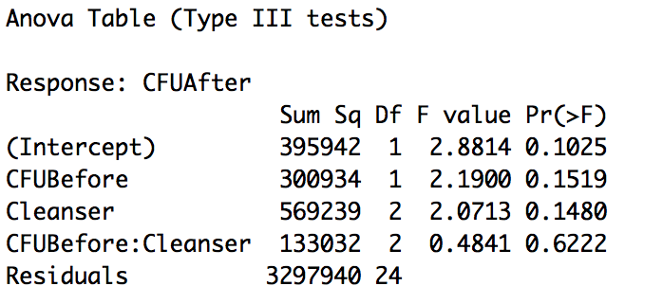
   2. Run the ANCOVA model (show the table) and summarize the results (3 pts)
      1. 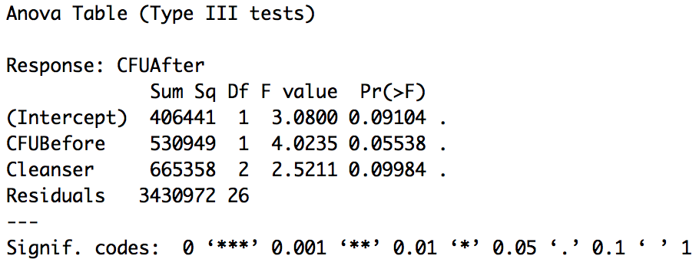
   3. Do a qqplot and histogram of the residuals to see if we can assume normality (3 pts)
      1. 